# Catch-22

[Andrew Schulz](mailto:aschulz6@uncc.edu), [Lutou Xiong](mailto:lxiong13@uncc.edu), Kevin Salley, [Irzem Ahmed](mailto:mahmed29@uncc.edu)

**Final Team Name:** Catch-22

**App Name:** Catch-22 Project management Tool

**Main Page:**

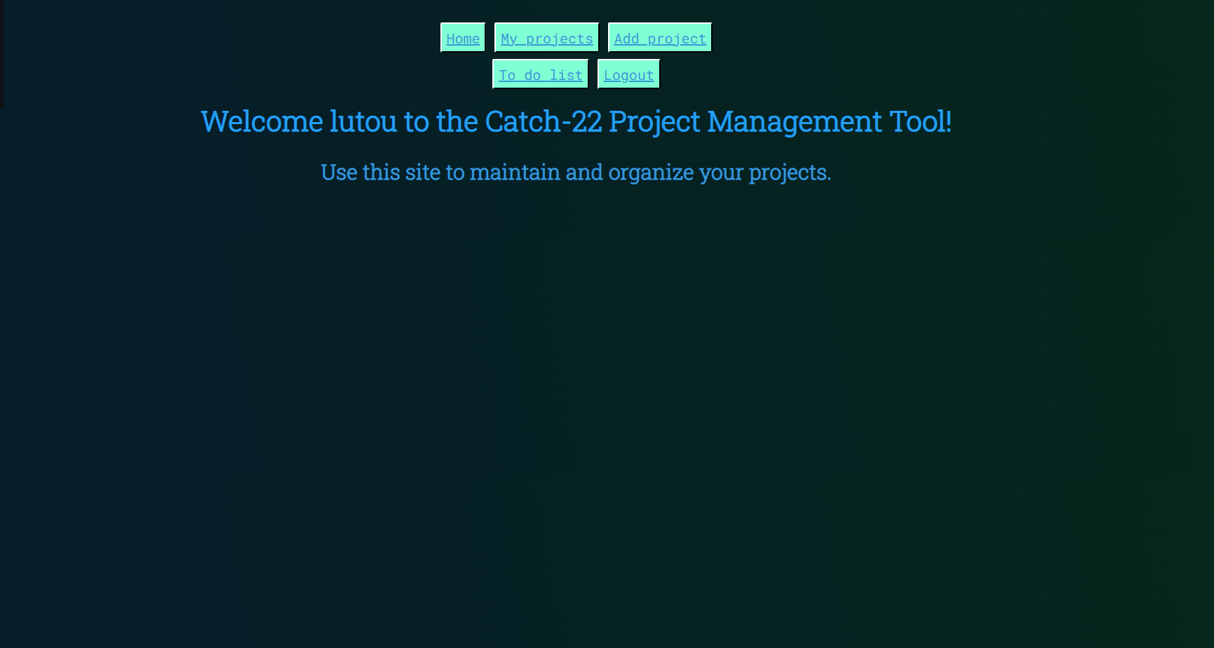

**Logged in^**

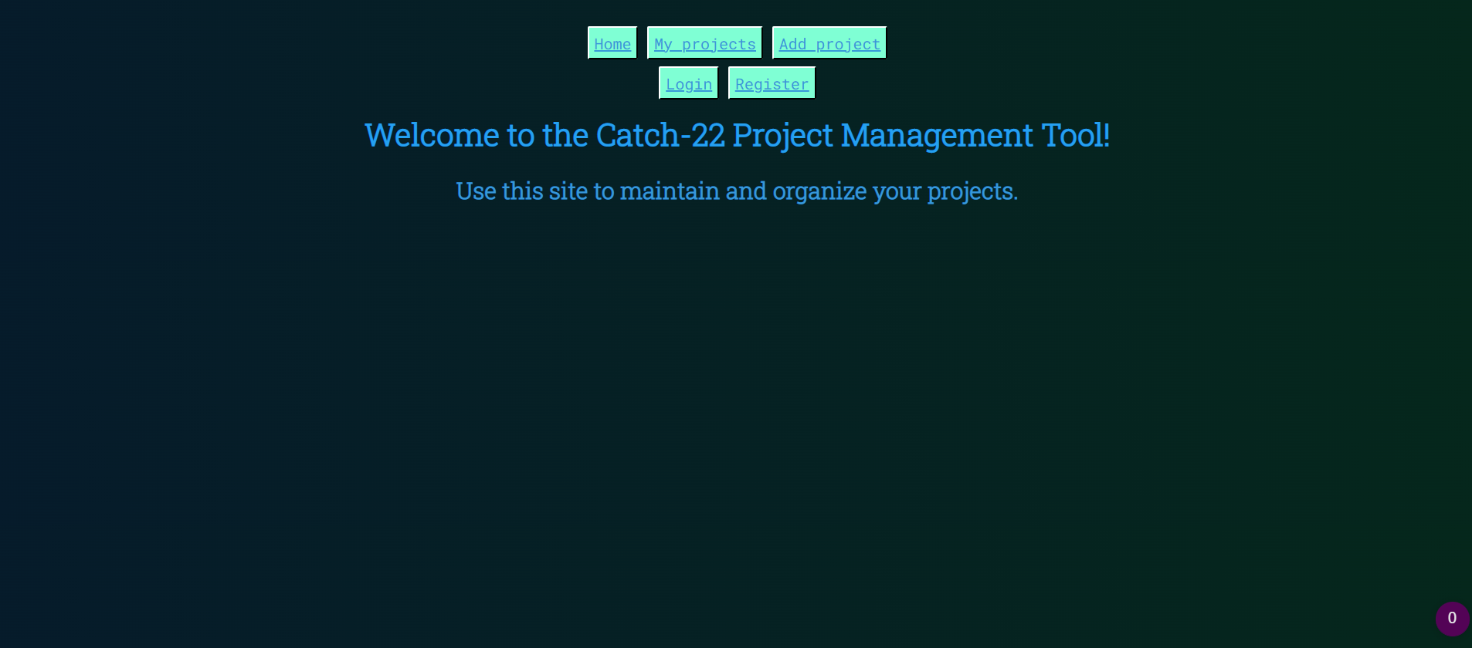

**Logged out^**

**Link to our project repo on GitHub:**

**https://github.com/Kenv96/catch-22-project**